**Chapter 1 The basic circuit and Laws**

**Ex1.1** The graph in the figure 1 shows charge $q(t)$ flowing past in a wire as a fuction of time.

1. Find the current $i(t)$ at t=1, 2.5, 4.5, and 5.5ms.
2. Sketch the variation of $i(t)$ versus time.

Hint: 1. $q\left(t\right)=\int_{to}^{t1}{idt}$ 2. the unit pC (picocoulomb) equals ${10}^{-12}$ Coulomb.

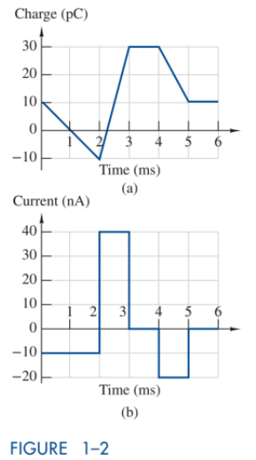

Figure 1

**Ex1.2** Find the power absorbed by each of the elements in Figure 2.

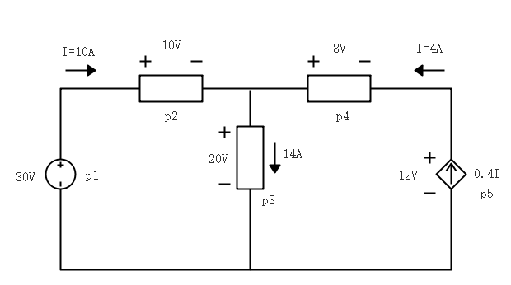

Figure 2

**Ex1.3** Find currents and voltages shown in Figure 3 . The voltage source is 30V.

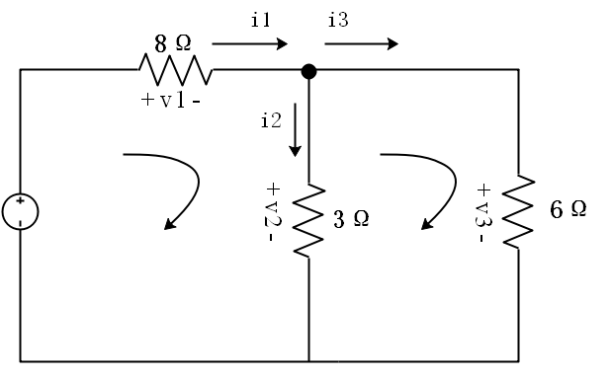

Figure 3